



Submitted by: Madan Lal

Instructor: Dr. Faheem Akhtar Rajput

**LAB # 04**

Sukkur IBA University, Nisar Ahmed Siddique Road, Sukkur

CMS ID: 053-18-0005

**Department of Computer Science**

Semester VI

**SIBAU**

**JAVA**

**Lab Tasks**

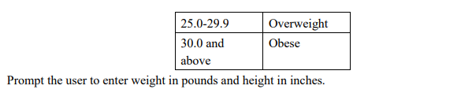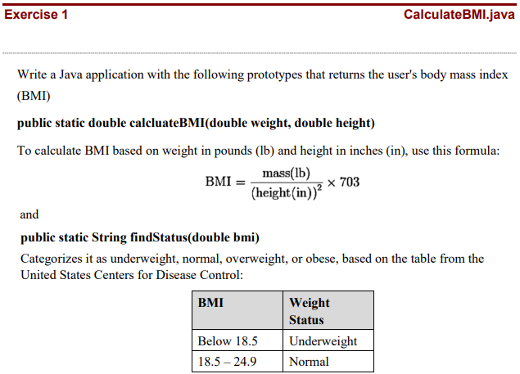

import java.util.Scanner;

class BMI {

    public static double calculateBMI(double weight, double height)

    {

        double BMI = (weight / (height*height));    //BMI formula correction BMI = kg/m2

        return BMI;

    }

    public static String findStatus(double bmi)

    {

        String result = "";

        if(bmi < 18.5)

        {

            result = "Underweight";

        }

        else if(bmi >= 18.5 && bmi <= 24.9)

        {

            result = "Normal";

        }

        else if(bmi >= 25.0 && bmi <= 29.9)

        {

            result = "Overweight";

        }

        else if(bmi >= 30)

        {

            result = "Obese";

        }

        return result;

    }

    public static void main(String args[])

    {

        Scanner input = new Scanner(System.in);

        System.out.print("Enter your Weight : ");

        double weight = input.nextDouble();

        System.out.print("Enter your height : ");

        double height = input.nextDouble();

        double BMI = calculateBMI(weight, height);

        String status = findStatus(BMI);

        System.out.println("Your BMI Status is : "+status);

    }

}

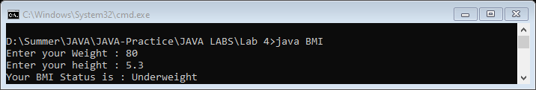

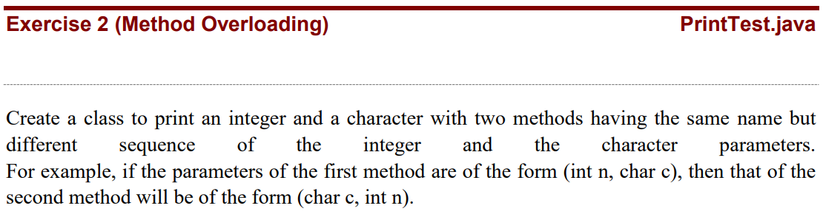

public class printTest {

    void test(int n, char c)

    {

        System.out.println("Number is \'"+n+"\' and Character is \'"+c+"\'.  (first-method called)");

    }

    void test(char c, int n)

    {

        System.out.println("Character is \'"+c+"\' and Number is \'"+n+"\'.  (second-method called)");

    }

    public static void main(String args[])

    {

        printTest obj = new printTest();

        obj.test(2,'a');

        obj.test('c',5);

    }

}

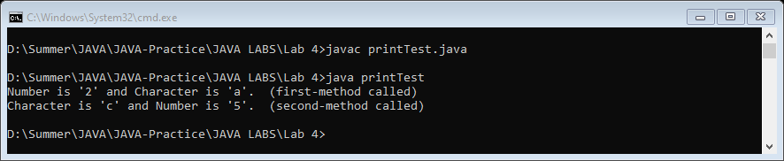

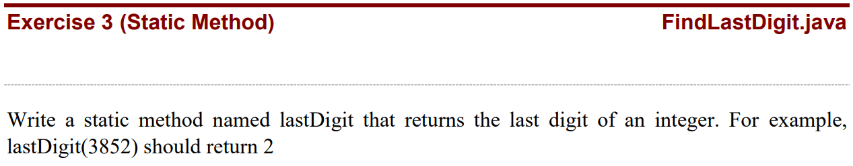

import java.util.Scanner;

public class findLastDigit {

    public static int lastDigit(int number)

    {

        String num = Integer.toString(number);

        char last = num.charAt(num.length() - 1);

        int LastDigit = Character.getNumericValue(last);

        return LastDigit;

    }

    public static void main(String args[])

    {

        Scanner input = new Scanner(System.in);

        System.out.print("Enter Number : ");

        int number = input.nextInt();

        int Last = lastDigit(number);

        System.out.println("\nLast digit is \'"+Last+"\'.");

    }

}

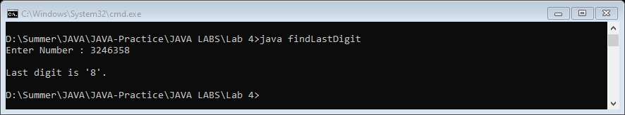

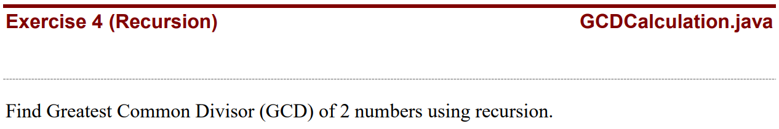

import java.util.Scanner;

public class GCD {

    public static void main(String args[])

    {

        Scanner input = new Scanner(System.in);

        System.out.print("Enter 1st number : ");

        int n1 = input.nextInt();

        System.out.print("Enter 2nd number : ");

        int n2 = input.nextInt();

        GCD obj = new GCD();

        int Result = obj.gcd(n1,n2);

        System.out.println(Result+" is the Greatest Common Divisor.");

    }

    int gcd(int n1, int n2)

    {

        if (n2 != 0)

            return gcd(n2, n1 % n2);

        else

            return n1;

    }

}

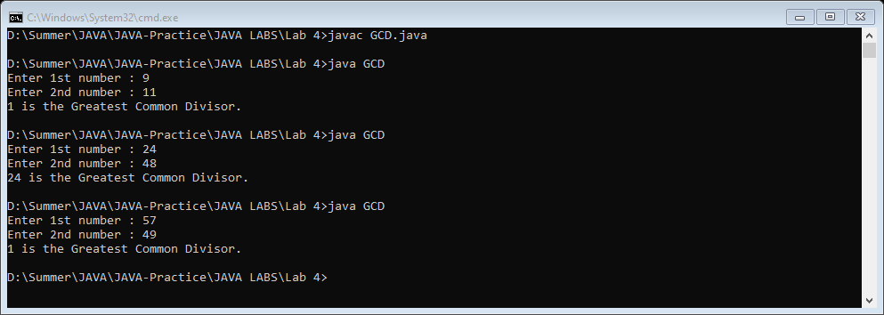

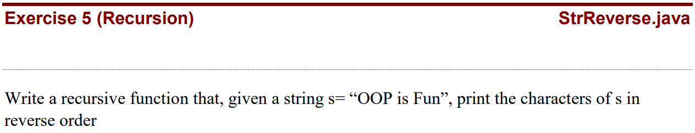

import java.util.Scanner;

public class StrReverse {

    int count =0;

    void printReverse(String name)

    {

        if(count != name.length())

        {

            count++;

            System.out.print(name.charAt(name.length()-count));

            printReverse(name);

        }

    }

    public static void main(String args[])

    {

        Scanner input = new Scanner(System.in);

        System.out.print("Enter Name : ");

        String name = input.nextLine();

        StrReverse obj = new StrReverse();

        obj.printReverse(name);

    }

}

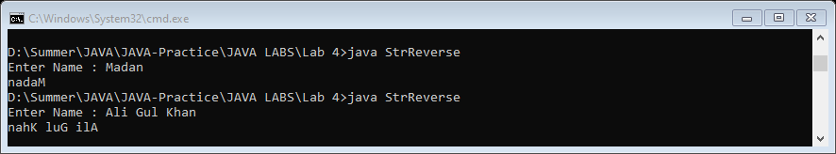

**1. Can constructors be static in java? Try it out and justify.**

No, we cannot define a static constructor in Java, If we are trying to define a constructor with the static keyword a compile-time error will occur. ... A constructor will be used to assign initial values for the instance variables. Both static and constructor are different and opposite to each other.

**2. Why use iterations when we have recursion and vice versa?**

Recursion allows you to allocate additional automatic objects at each function call. The iterative alternative is to repeatedly dynamically allocate or resize memory blocks.

**End of Lab 4**